Examples of map function

**Mapping array of arrays**

Let's see how to map array of arrays

import React from 'react'

import ReactDOM from 'react-dom'

const skills = [

['HTML', 10],

['CSS', 7],

['JavaScript', 9],

['React', 8],

]

// Skill Component

const Skill = ({ skill: [tech, level] }) => (

<li>

{tech} {level}

</li>

)

// Skills Component

const Skills = ({ skills }) => {

const skillsList = skills.map((skill) => <Skill skill={skill} />)

console.log(skillsList)

return <ul>{skillsList}</ul>

}

const App = () => {

return (

<div className='container'>

<div>

<h1>Skills Level</h1>

<Skills skills={skills} />

</div>

</div>

)

}

const rootElement = document.getElementById('root')

ReactDOM.render(<App />, rootElement)

**Mapping array of objects**

Rendering array of objects

import React from 'react'

import ReactDOM from 'react-dom'

const countries = [

{ name: 'Finland', city: 'Helsinki' },

{ name: 'Sweden', city: 'Stockholm' },

{ name: 'Denmark', city: 'Copenhagen' },

{ name: 'Norway', city: 'Oslo' },

{ name: 'Iceland', city: 'Reykjavík' },

]

// Country component

const Country = ({ country: { name, city } }) => {

return (

<div>

<h1>{name}</h1>

<small>{city}</small>

</div>

)

}

// countries component

const Countries = ({ countries }) => {

const countryList = countries.map((country) => <Country country={country} />)

return <div>{countryList}</div>

}

// App component

const App = () => (

<div className='container'>

<div>

<h1>Countries List</h1>

<Countries countries={countries} />

</div>

</div>

)

const rootElement = document.getElementById('root')

ReactDOM.render(<App />, rootElement)

**Key in mapping arrays**

Keys help React to identify items which have changed, added, or removed. Keys should be given to the elements inside the array to give the elements a stable identity. The key should be unique. Mostly data will come with as an id and we can use id as key. If we do not pass key to React during mapping it raises a warning on the browser. If the data does not have an id we have to find a way to create a unique identifier for each element when we map it. See the following example:

import React from 'react'

import ReactDOM from 'react-dom'

const Numbers = ({ numbers }) => {

// modifying array to array of li JSX

const list = numbers.map((num) => <li key={num}>{num}</li>)

return list

}

const App = () => {

const numbers = [1, 2, 3, 4, 5]

return (

<div className='container'>

<div>

<h1>Numbers List</h1>

<ul>

<Numbers numbers={numbers} />

</ul>

</div>

</div>

)

}

const rootElement = document.getElementById('root')

ReactDOM.render(<App />, rootElement)

Let's also add in key in countries mapping example.

import React from 'react'

import ReactDOM from 'react-dom'

const countries = [

{ name: 'Finland', city: 'Helsinki' },

{ name: 'Sweden', city: 'Stockholm' },

{ name: 'Denmark', city: 'Copenhagen' },

{ name: 'Norway', city: 'Oslo' },

{ name: 'Iceland', city: 'Reykjavík' },

]

// Country component

const Country = ({ country: { name, city } }) => {

return (

<div>

<h1>{name}</h1>

<small>{city}</small>

</div>

)

}

// countries component

const Countries = ({ countries }) => {

const countryList = countries.map((country) => (

<Country key={country.name} country={country} />

))

return <div>{countryList}</div>

}

const App = () => (

<div className='container'>

<div>

<h1>Countries List</h1>

<Countries countries={countries} />

</div>

</div>

)

const rootElement = document.getElementById('root')

ReactDOM.render(<App />, rootElement)

**Exercises**

**Exercises: Level 1**

1. Why you need to map an array ?
2. Why we need keys during mapping an array ?
3. What is the importance of destructuring your code ?
4. Does destructuring make your code clean and easy to read ?

**Exercises: Level 2**

1. In the following design, evens are green, odds are yellow and prime numbers are red. Build the following colors using React component

[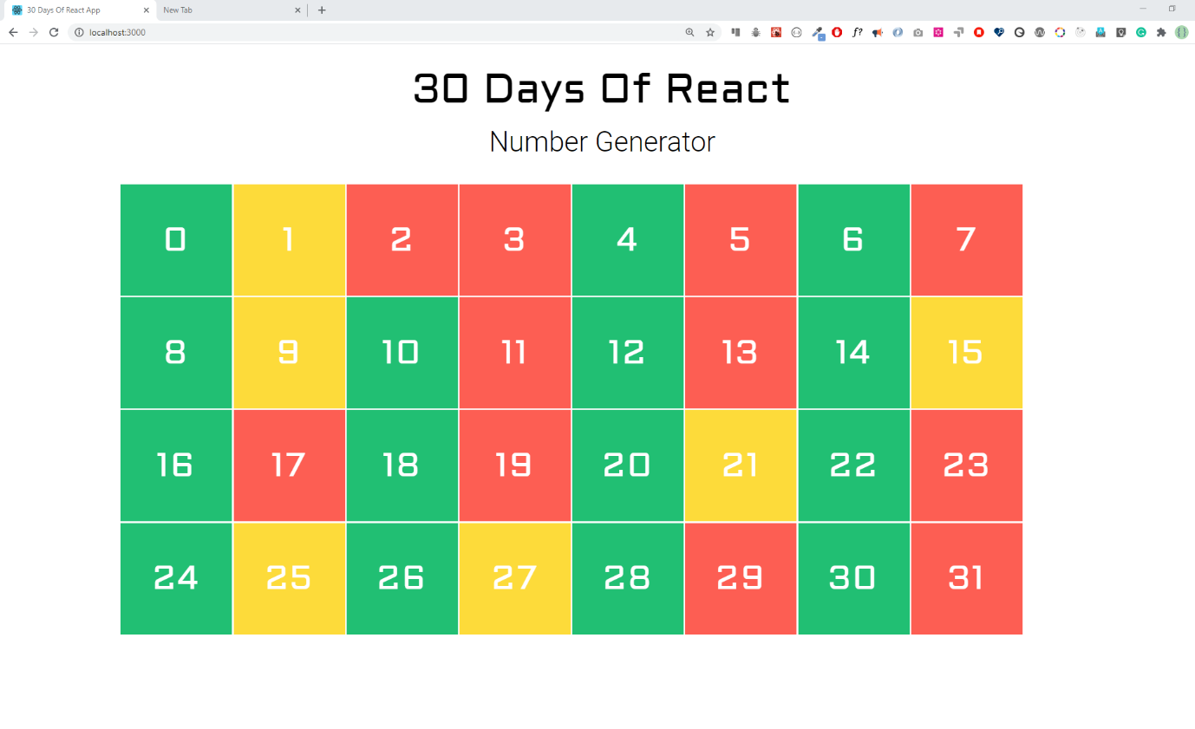](https://github.com/Asabeneh/30-Days-Of-React/blob/master/images/day_6_number_generater_exercise.png)

1. Create the following hexadecimal colors using React component

[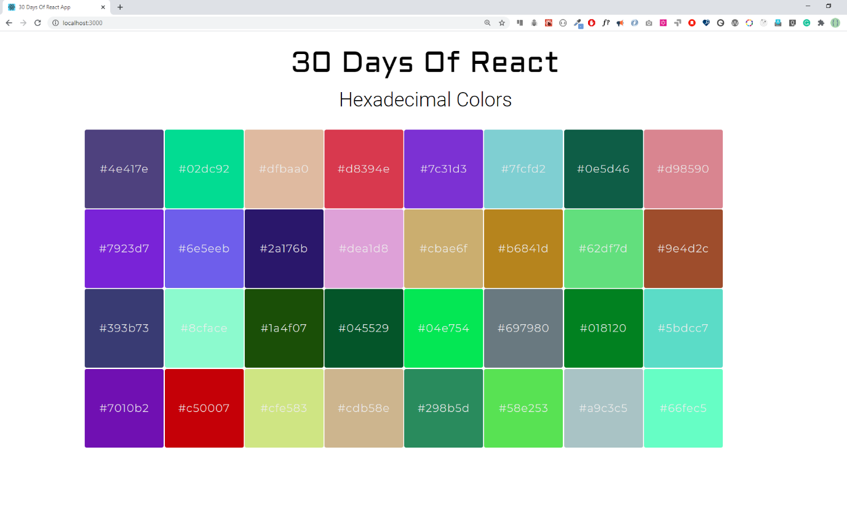](https://github.com/Asabeneh/30-Days-Of-React/blob/master/images/day_6_hexadecimal_colors_exercise.png)

**Exercises: Level 3**

1.Make the following bar group using the given [data](https://github.com/Asabeneh/30-Days-Of-React/blob/master/06_Day_Map_List_Keys/06_map_list_keys_boilerplate/src/data/ten_most_highest_populations.js)

[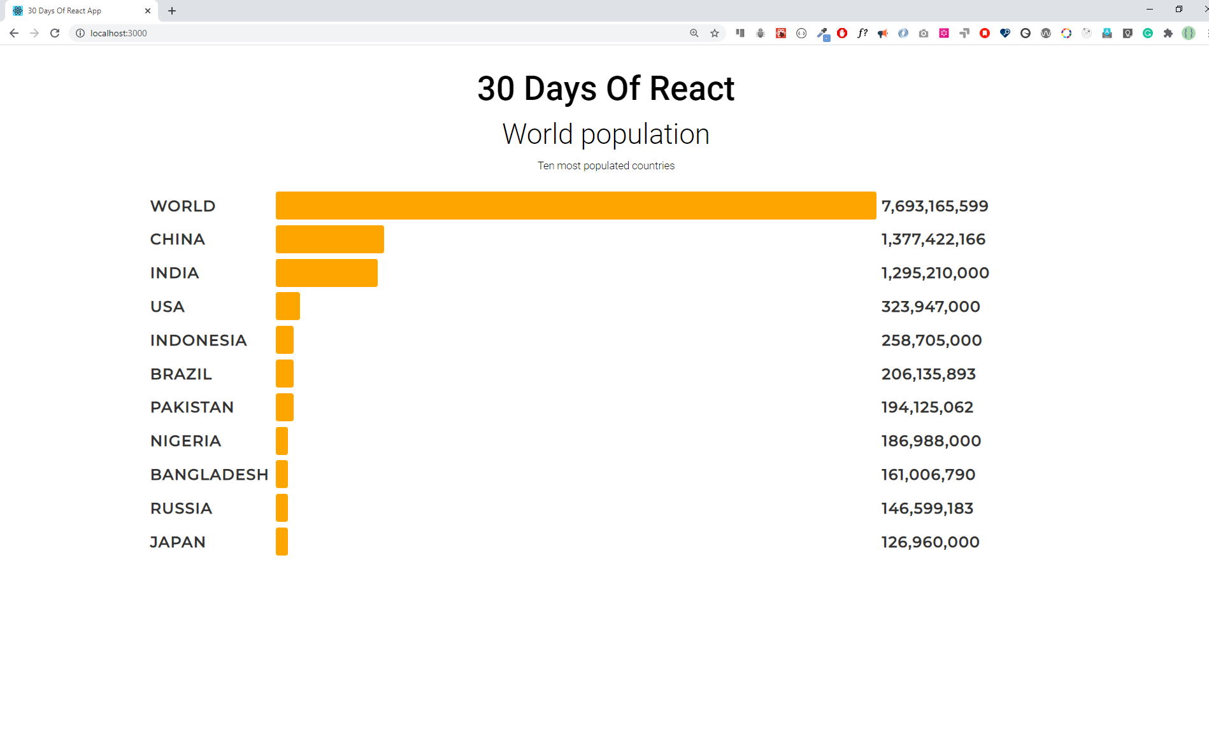](https://github.com/Asabeneh/30-Days-Of-React/blob/master/images/day_6_ten_highest_populations_exercise.png)